Final Project Progress Report   
CS 6610-001 Spring 2019

# Position Based Fluids

So far, I’ve been able to work out quite a bit of the kinks associated with my past code. Having a codebase to start from for a project of this magnitude was essential, so I refactored my existing code to account for the change in requirements with respect to my shaders, variables, buffers, etc. That alone took quite a bit of time. I then began modifying my code to create the scene and the background to attempt to mimic the scene that the original paper showed. Their lighting quite obviously used more point lights that we had in past assignments so that was another factor to consider in this initial phase and I added more uniforms to pass in the positions of the virtual point lights to help with lighting. The bunny and the checker pattern in the background took more time than they should have with little GLSL issues. I’ve moved on from there to begin to visualize the particles, and I began initially with simply displaying them to the screen. They are currently generated in the geometry shader but I’m having quite the time trying to figure out how to compute the positions of each particle and simulate the collision. I’m currently working on the timestep, but I’ll need to visit the TA to help conceptualize some of the computation and possibly introduce a separate compute shader. I must track each particle with respect to its neighbor and with respect to some arbitrary bounding box that I specify. Before the deadline I will have corrected this, got it running smoothly and for aesthetics, will likely change my particle shape to something more visually appealing.

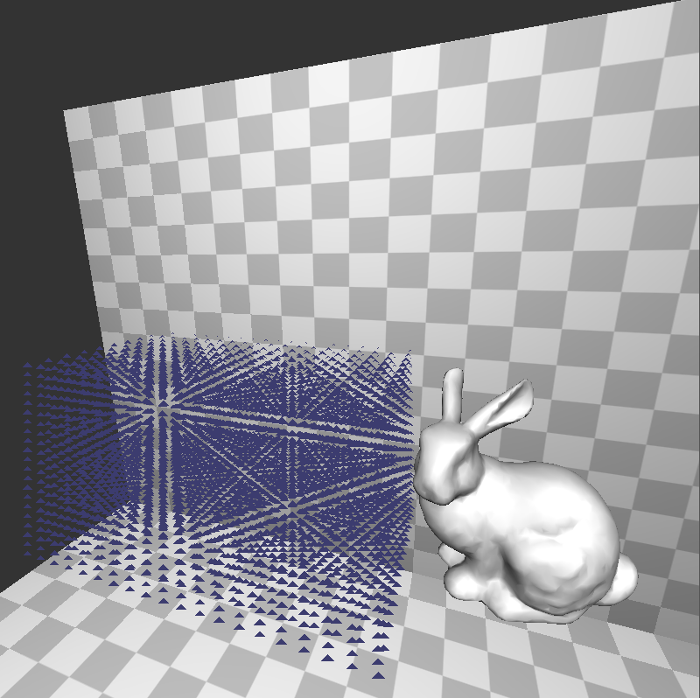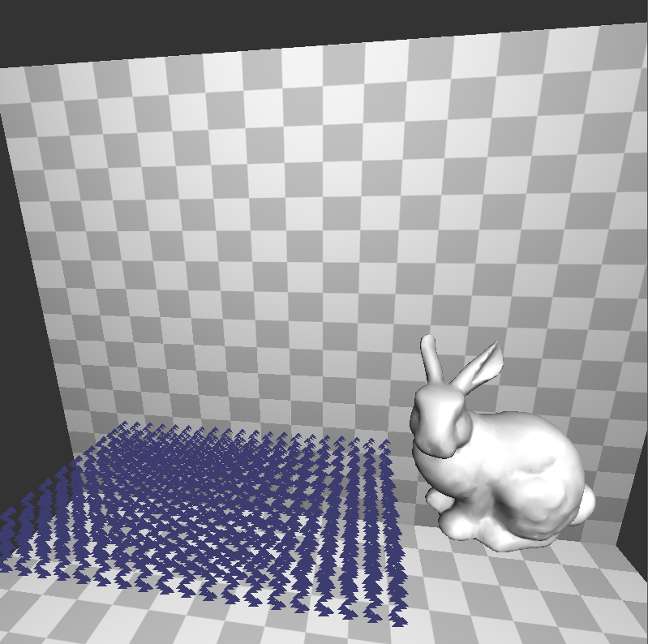

No collisions yet: